Lab Objective

Learn how to move Operations Masters from one domain controller to the other

**Lab Procedures**

**1.** Log in to Server01 as the **Contoso\administrator** user account. The Server Manager console opens.

**2.** On Server Manager, click Tools > Active Directory Users and Computers. The Active Directory Users and Computers console opens.

**3.** Right-click contoso.com and click Change Domain Controller. Click Server01.contoso.com and click OK.

**4.** Right-click contoso.com and click Operations Masters. The Operations Masters dialog box opens as shown in Figure 16-2.

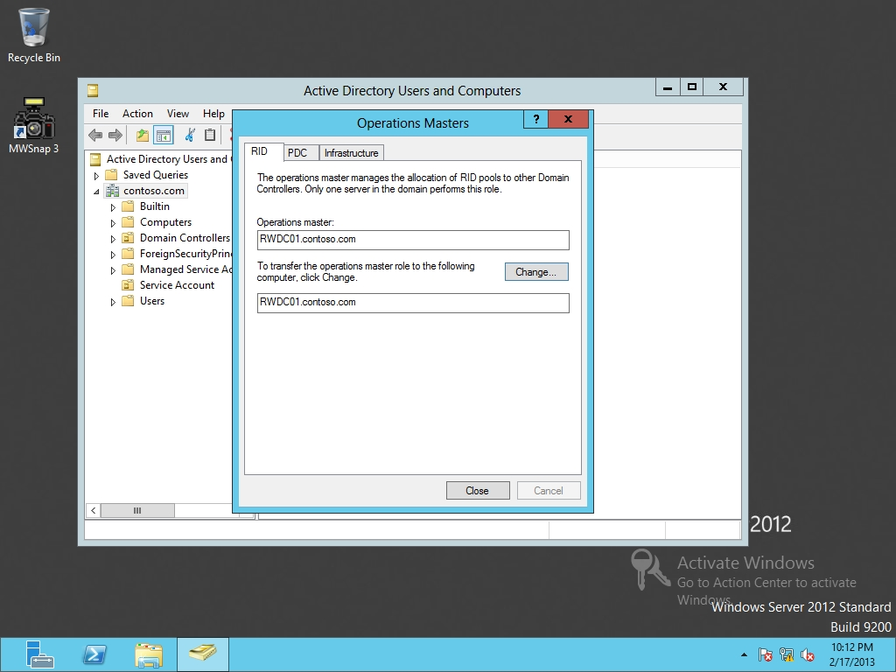

Figure 16-2

Viewing the current domain-level operations masters

**5.** To transfer the RID from RWDC01 to Server01, click Change on the RID tab. When it asks if you are sure, click Yes. When the Operations Master role is transferred, click OK.

**6.** Click the PDC tab. Transfer the PDC Emulator to Server01.

**7.** Click the Infrastructure tab. Transfer the Infrastructure to Server01.

**8.** Close the Operations Masters dialog box.

**9.** Close the Active Directory Users and Computers console.

**10.** On Server01, using Server Manager, click Tools > Active Directory Domains and Trusts. The Active Domains and Trusts console opens.

**11.** Right-click Active Directory Domains and Trusts and click Change Active Directory Domain Controller. Click Server01.contoso.com. Click OK.

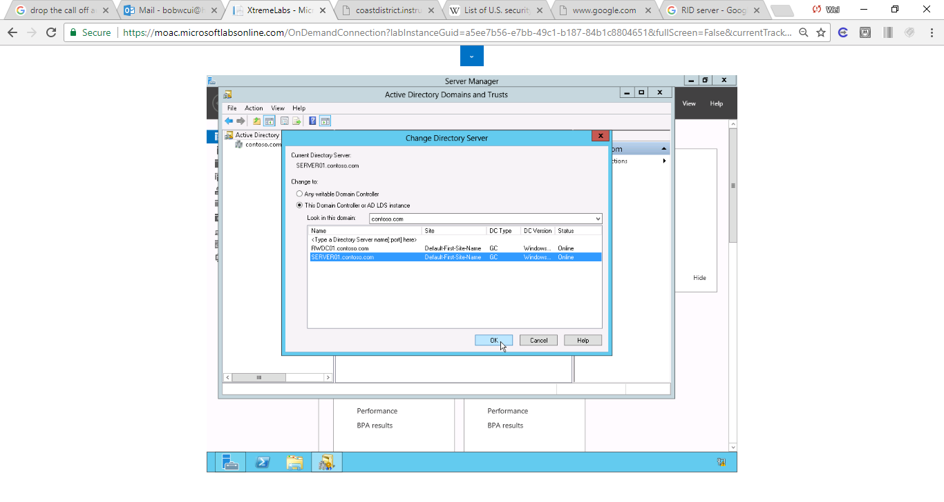

Figure 1 screenshot shows SERVER01 is one of the Active Directory Domain Controllers.

**12.** Right-click Active Directory Domains and Trusts and select Operations Master. The Operations Master dialog box showing current Domain Naming Operations Master opens.

**13.** Take a screen shot of the Active Directory Domains and Trusts window by pressing Alt+Prt Scr and then paste it into your Lab16_worksheet file in the page provided by pressing Ctrl+V.

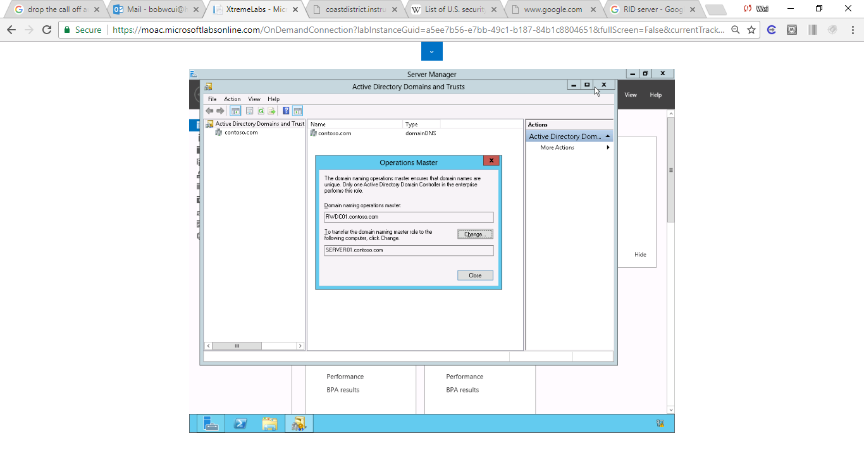

Figure 2. Snapshot shows current domain naming operations masters: RWDC01 and to-transfer domain master SERVER01

**14.** To transfer the Operations Master, click Change. When you're prompted to confirm, click Yes. When the transfer is sucessful, click OK.

**15.** Click Close to close the Operations Master dialog box.

**16.** Close the Active Directory Domains and Trusts console.

**17.** Right-click the start button and select Command Prompt (Admin). The command prompt opens.

**18.** At the command prompt, execute the following command so that you can use the Schema Management console.

Regsvr32 schmmgmt.dll

**19.** When the schmmgmt.dll is registered, click OK.

**20.** At the command prompt, execute the mmc command. The MMC console opens.

**21.** Open the File menu and select Add/Remove Snap-in. The Add or Remove Snap-ins dialog box opens.

**22.** Select Active Directory Schema and click Add. Then click OK to close the Add/Remove Snap-ins dialog box.

**23.** Right-click Active Directory Schema and click Change Active Directory Domain Controller. Click Server01.contoso.com and click OK. When it gives you a warning, click OK.

**24.** Right-click Active Directory Schema and select Operations Master. The Change Schema Master dialog box opens.

**25.** To transfer the Schema Master to Server01, click Change. When it asks if you are sure, click Yes. When the Operations Master is transferred, click OK.

**26.** Click Close to close the Change Schema Master dialog box.

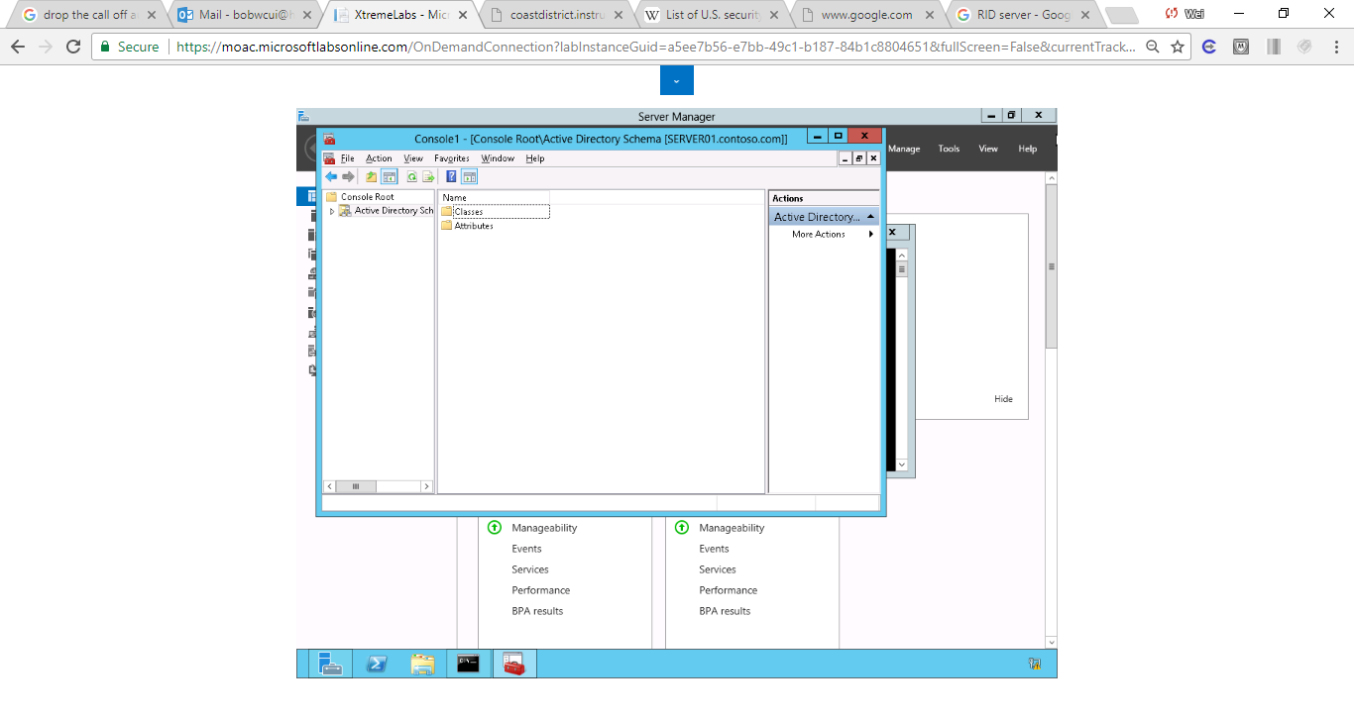

Figure 3 screenshot shows the Operations Master is transferred to Server01 successfully.

**27.** Close the MMC console. If you are asked to save the console settings, click No. Close the command prompt window.

End of exercise

**Lab Summary**

During this exercise, I transferred the Operations Masters to another domain controller. Active Directory defines five operations master roles: schema master domain naming master, relative identifier (RID) master, primary domain controller emulator, and infrastructure master. The schema master and domain naming master are per-forest roles, Therefore, there is only one schema master and one domain naming master in the entire forest. The other operations master roles are per-domain roles. Each domain in a forest has its own RID master, primary domain controller emulator, and infrastructure master. So, in a forest with only one domain there are five operations master roles. In a forest with more than one domain there are more than five roles because the per-domain roles need to exist in each domain.